Williamsburg Buddhist Sangha
Board Position Overview
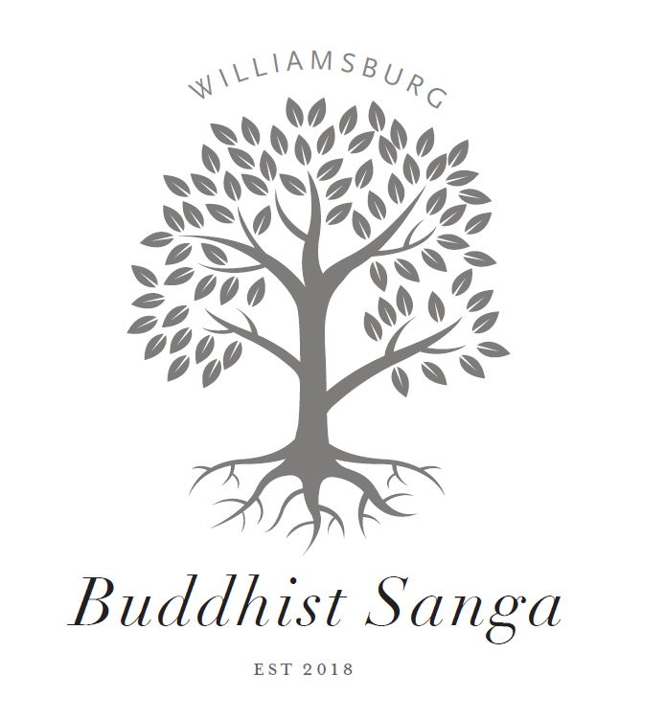

Williamsburg Buddhist Sangha – Who We Are
The Williamsburg Buddhist Sangha provides the residents of Williamsburg and the surrounding areas a community for mindful growth and practice based upon the teachings of Buddhism by offering a regular schedule of meditation and study groups, special events, and other resources.
All WBS activities, operations and governance are rooted in core values consistent with Buddhist ethical teachings, as outlined in our Vision, Mission, and Values statement. In keeping with the emerging expression of Buddhism in the West, the WBS does not align with any one specific lineage of Buddhism, but welcomes diverse points of view among Buddhist traditions, including secular applications manifest in Mindfulness meditation and practices.
Our community is open to anyone interested in Mindfulness meditation and/or Buddhist teachings and practices, from the casual meditator to the most devoted student of Buddhist practice. We value diversity among our participants, teachers, and other volunteers, including those who bring complementary practices from other spiritual traditions. We are committed to broader service and establishing working relationships with other community groups, and we strive to be creative in our format, so that we may be relevant and accessible to American culture, issues, and vernacular.
We do not require payment for any of our teachings, programs, or events. The WBS is primarily supported by voluntary donations from the community.
WBS Board of Directors – General Responsibilities
The Williamsburg Buddhist Sangha Board of Directors is responsible for all operational and governing functions, including determining priorities, setting policy, overseeing activities, approving the budget, accomplishing administrative tasks, and otherwise performing work needed to deliver programs and services to our members. It operates as a “Sangha within the sangha,” seeking to embody Buddhist principles and practices in every facet of our interactions and initiatives, supporting each other and deepening our own practices in the process.
Each Director (Board member) holds some primary responsibility within the Sangha, either as an Officer or Committee Chair, or some other capacity mutually agreed upon. All members of the WBS leadership team (board and committees) serve on a volunteer basis.
The WBS Board currently meets monthly via Zoom video conference at a time mutually agreeable to the members. Between meetings, business may be conducted via email discussion or small task group meetings. Committees may schedule their own regular or ad hoc meetings as needed to fulfill their responsibilities.
The general responsibilities of a WBS Director are as follows:
- Seek at all times to engage in a spirit of open-mindedness, compassion, right speech, right action and otherwise in keeping with WBS core values.
- Attend and participate in monthly Board meetings. Should circumstances prevent attendance, notify the rest of the Board in advance (if possible), read all materials associated with the meeting, and provide input on issues under discussion.
- Respond in as timely a manner as possible to WBS Board emails, which may include discussion streams and requests for information and/or feedback.
- Complete tasks or assignments or otherwise fulfill leadership responsibilities in accordance with role as an officer, committee chair, or other.
- Attend/participate in Sangha activities and events as able.
The Compassion in Action chair Description
The Compassion in Action chair will serve on the Board of Directors and be responsible for Compassion in Action initiatives. This would include projects that provide our members opportunities to support those in our greater community in need. If you share our values and would like to make a difference in our community, our Sangha would value your time and talents. For more information you can apply here. If interested, your application should be submitted no later than March 15, 2024.
All Board members work in collaboration with one another, and training and consultation are available as needed.

